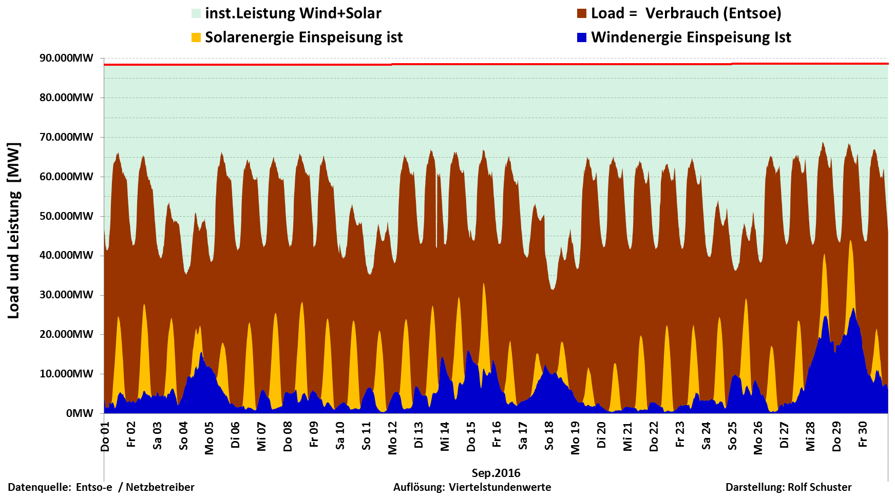

Sep 2016 | Load D | Wind | Solar | Wind + Solar | Proz. der Nennleist.
inst. Nennleistung |  | 48.197MW | 40.468MW | 88.664MW
Max | 68.925MW | 26.923MW | 24.377MW | 44.120MW | 49,76%
Mittelwert | 52.743MW | 5.840MW | 5.317MW | 11.150MW | 12,58%
Min | 31.298MW | 394MW | 0MW | 677MW | 0,76%
Summe Monat | 37.975GWh | 4.205GWh | 3.828GWh | 8.028GWh | 21,14%

